practice

varun

2024-01-29

## R Markdown

Hello world

data = read.csv('/Users/trsaivarun/Desktop/R programs/week 1/Cereals.csv')  
head(data)

## Cereal.name Supplier Cold.or.Hot calories protein fat sodium  
## 1 100%_Bran N C 70 4 1 130  
## 2 100%_Natural_Bran Q C 120 3 5 15  
## 3 All-Bran K C 70 4 1 260  
## 4 All-Bran_with_Extra_Fiber K C 50 4 0 140  
## 5 Almond_Delight R C 110 2 2 200  
## 6 Apple_Cinnamon_Cheerios G C 110 2 2 180  
## fiber carbo sugars potass vitamins rating  
## 1 10.0 5.0 6 280 25 68.40297  
## 2 2.0 8.0 8 135 0 33.98368  
## 3 9.0 7.0 5 320 25 59.42551  
## 4 14.0 8.0 0 330 25 93.70491  
## 5 1.0 14.0 8 NA 25 34.38484  
## 6 1.5 10.5 10 70 25 29.50954

str(data)

## 'data.frame': 77 obs. of 13 variables:  
## $ Cereal.name: chr "100%_Bran" "100%_Natural_Bran" "All-Bran" "All-Bran_with_Extra_Fiber" ...  
## $ Supplier : chr "N" "Q" "K" "K" ...  
## $ Cold.or.Hot: chr "C" "C" "C" "C" ...  
## $ calories : int 70 120 70 50 110 110 110 130 90 90 ...  
## $ protein : int 4 3 4 4 2 2 2 3 2 3 ...  
## $ fat : int 1 5 1 0 2 2 0 2 1 0 ...  
## $ sodium : int 130 15 260 140 200 180 125 210 200 210 ...  
## $ fiber : num 10 2 9 14 1 1.5 1 2 4 5 ...  
## $ carbo : num 5 8 7 8 14 10.5 11 18 15 13 ...  
## $ sugars : int 6 8 5 0 8 10 14 8 6 5 ...  
## $ potass : int 280 135 320 330 NA 70 30 100 125 190 ...  
## $ vitamins : int 25 0 25 25 25 25 25 25 25 25 ...  
## $ rating : num 68.4 34 59.4 93.7 34.4 ...

This is an R Markdown document. Markdown is a simple formatting syntax for authoring HTML, PDF, and MS Word documents. For more details on using R Markdown see <http://rmarkdown.rstudio.com>.

When you click the **Knit** button a document will be generated that includes both content as well as the output of any embedded R code chunks within the document. You can embed an R code chunk like this:

summary(cars)

## speed dist   
## Min. : 4.0 Min. : 2.00   
## 1st Qu.:12.0 1st Qu.: 26.00   
## Median :15.0 Median : 36.00   
## Mean :15.4 Mean : 42.98   
## 3rd Qu.:19.0 3rd Qu.: 56.00   
## Max. :25.0 Max. :120.00

## Including Plots

You can also embed plots, for example:

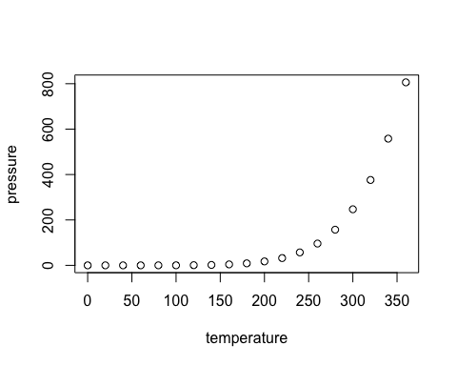

Note that the echo = FALSE parameter was added to the code chunk to prevent printing of the R code that generated the plot.